THE RIVERSIDE PRACTICE

NEW PATIENT REGISTRATION/HEALTH QUESTIONNAIRE

Introduction

This questionnaire can be used to capture data for new patient registrations. It will also help to establish a base-line view of the patient’s lifestyle and will assist the nurse/doctor in carrying out a new patient health check. The information provided will also assist in the identification of “at risk” patients and focus care advice on at-risk areas.

Related Information: Ethnic Origin Monitoring procedure [*]

New Patient Registration Policy [*]

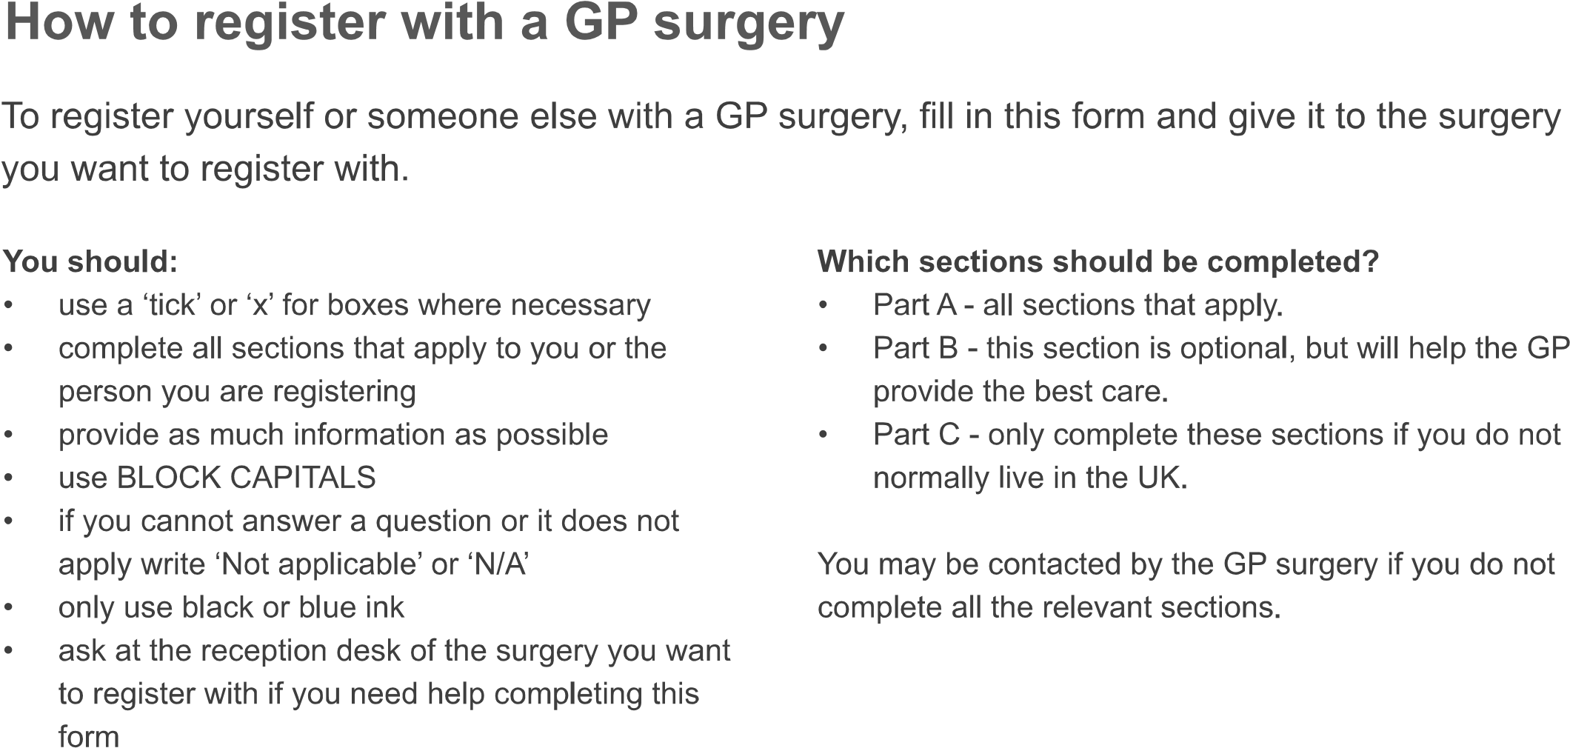


 | 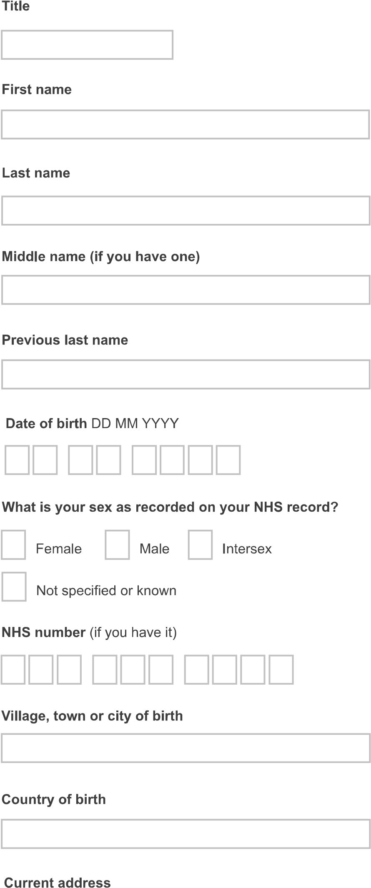 |  | 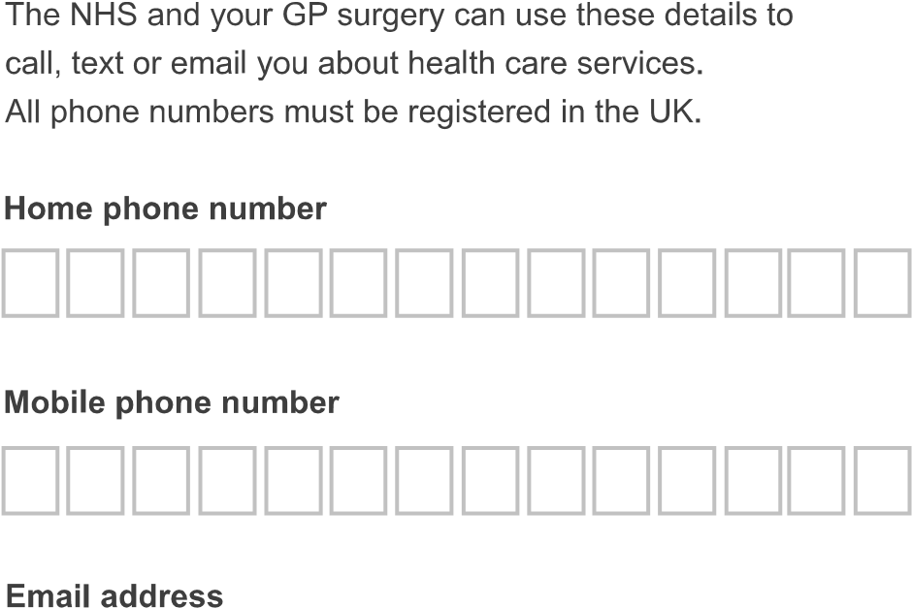  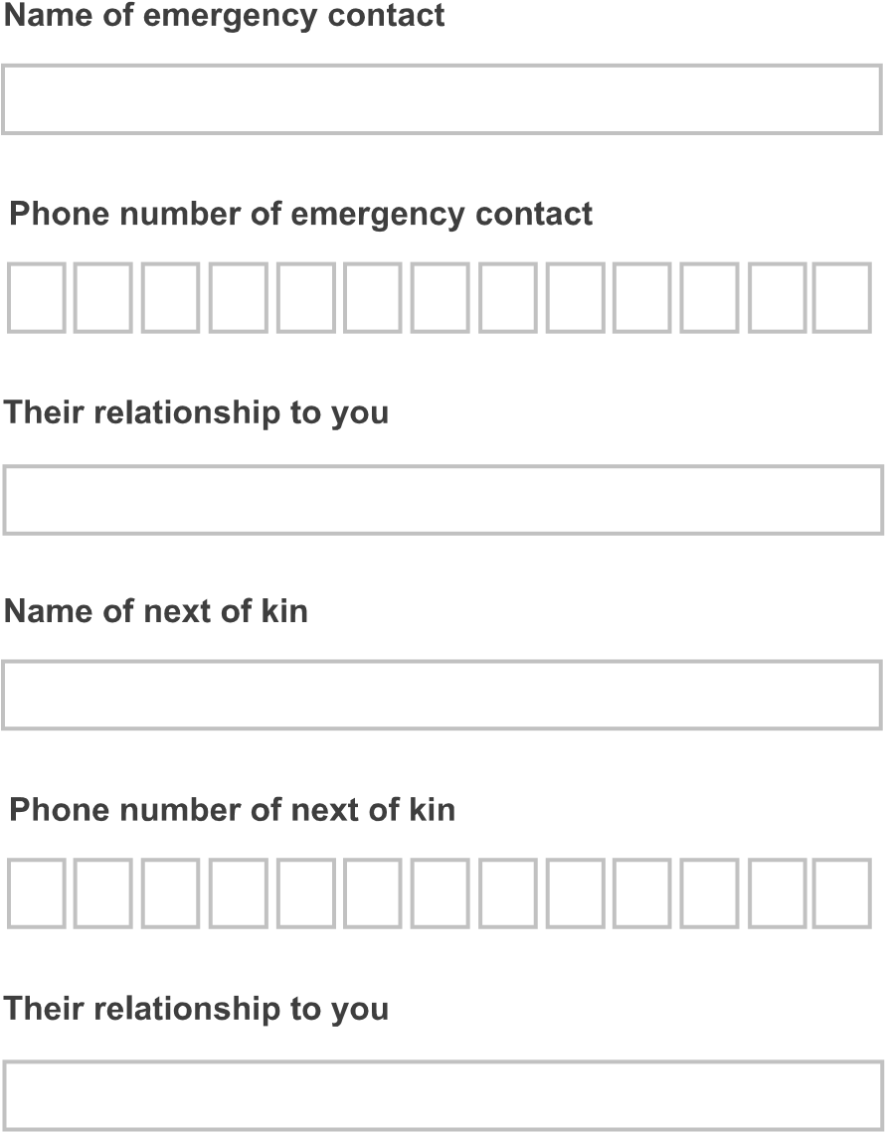

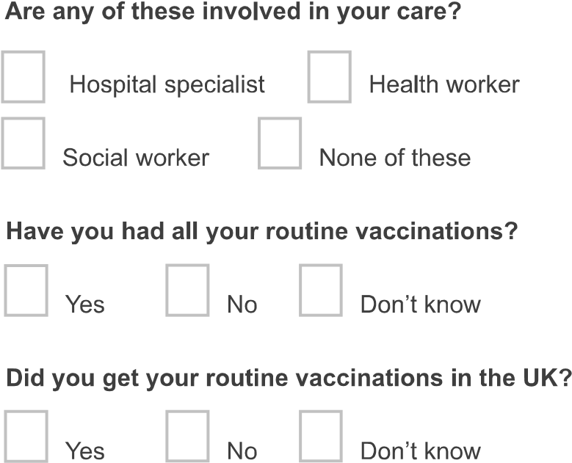

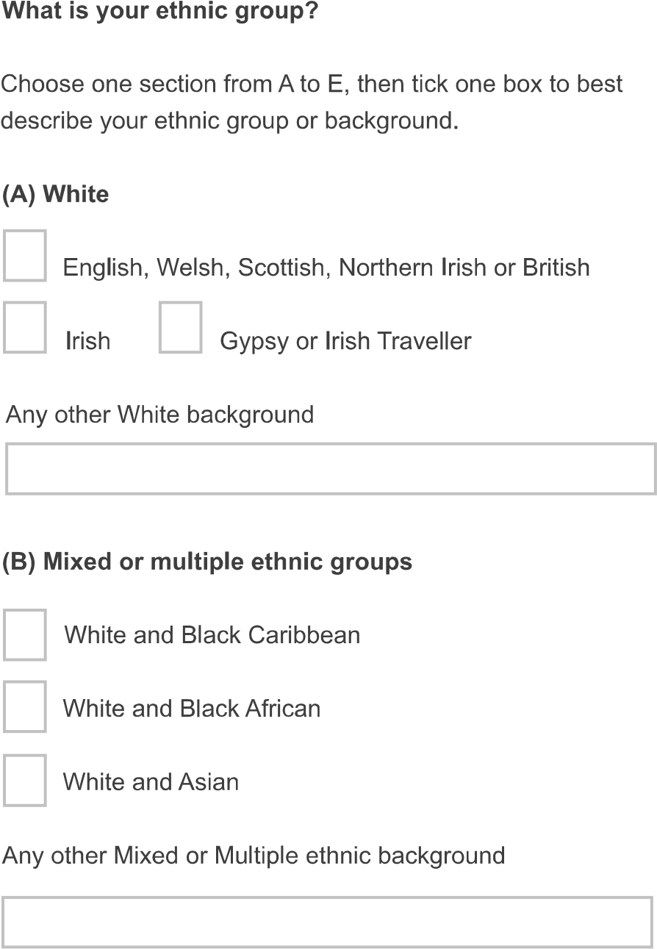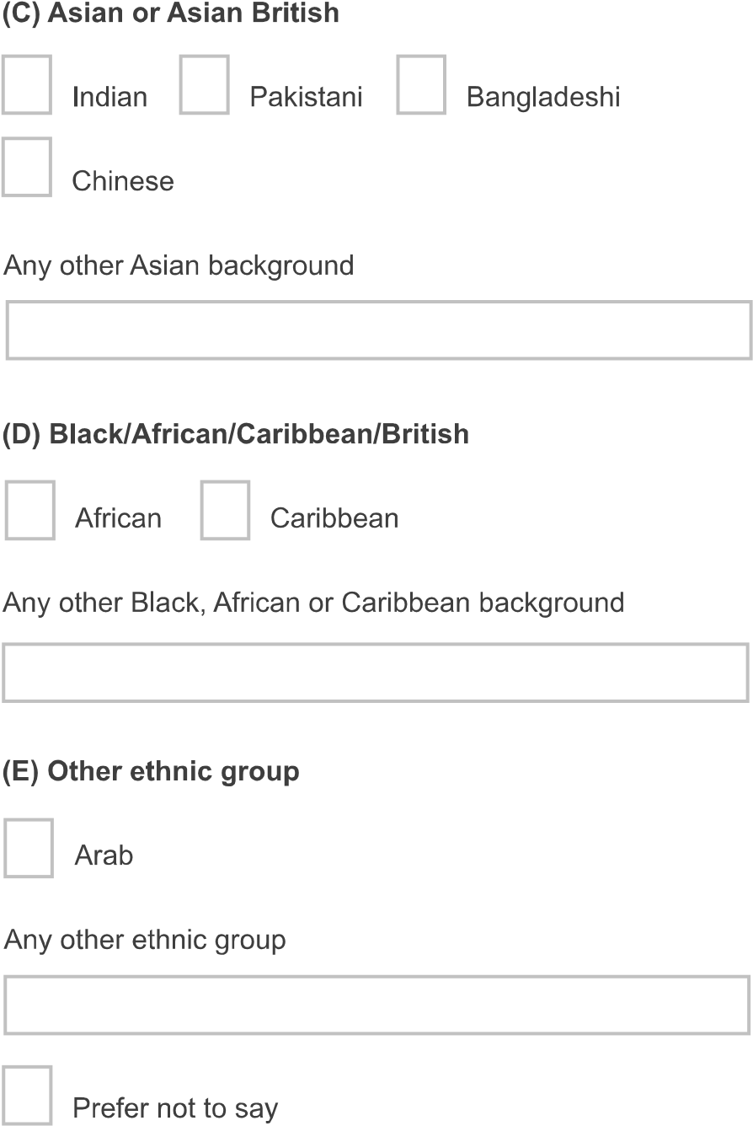

 | 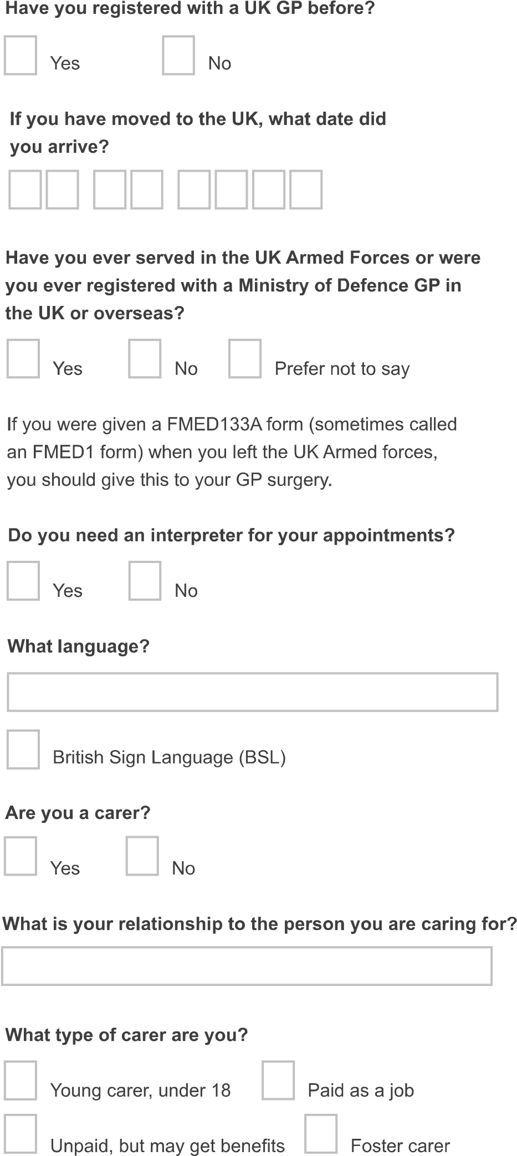 |  | 